DVC remote created and updated initial dataset and next two sets here

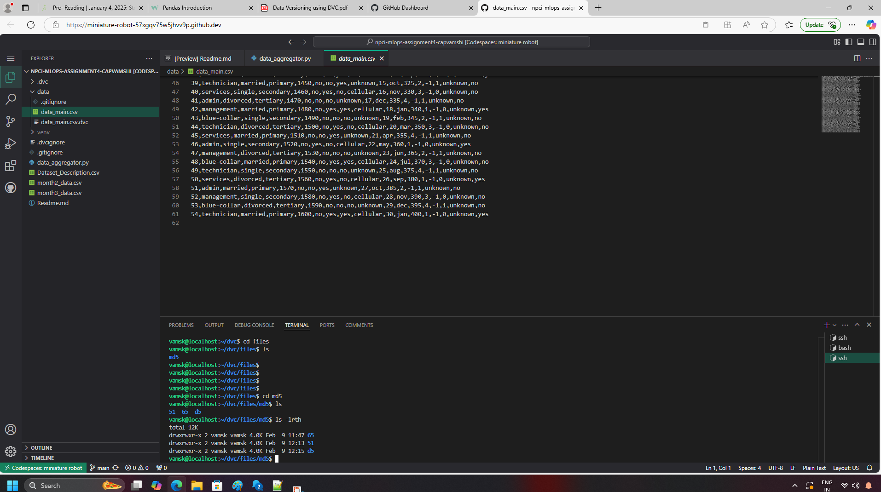

Track changing the version tag as v1 v1.1 and v1.2

